COVID-19 Story Map (With url)

Title Page:

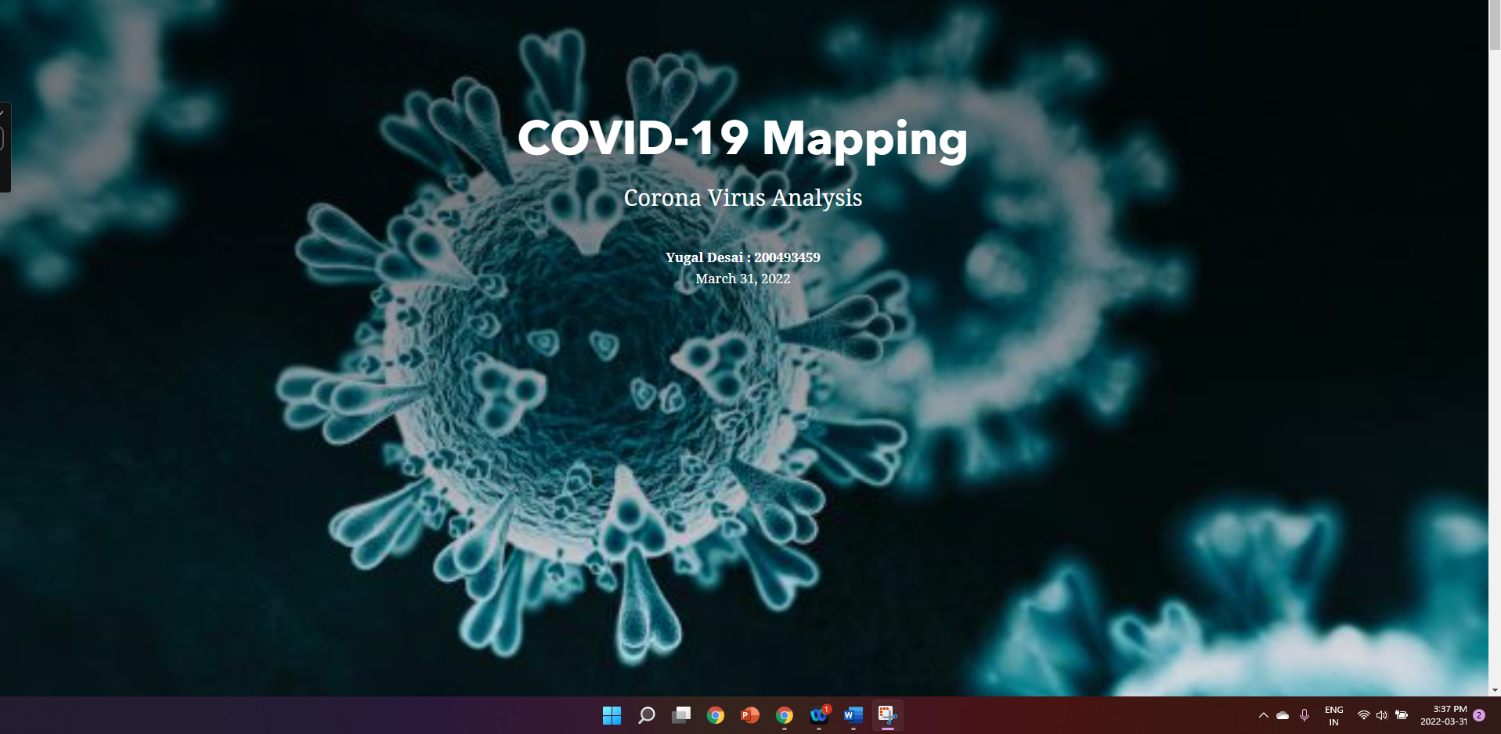

Introduction:

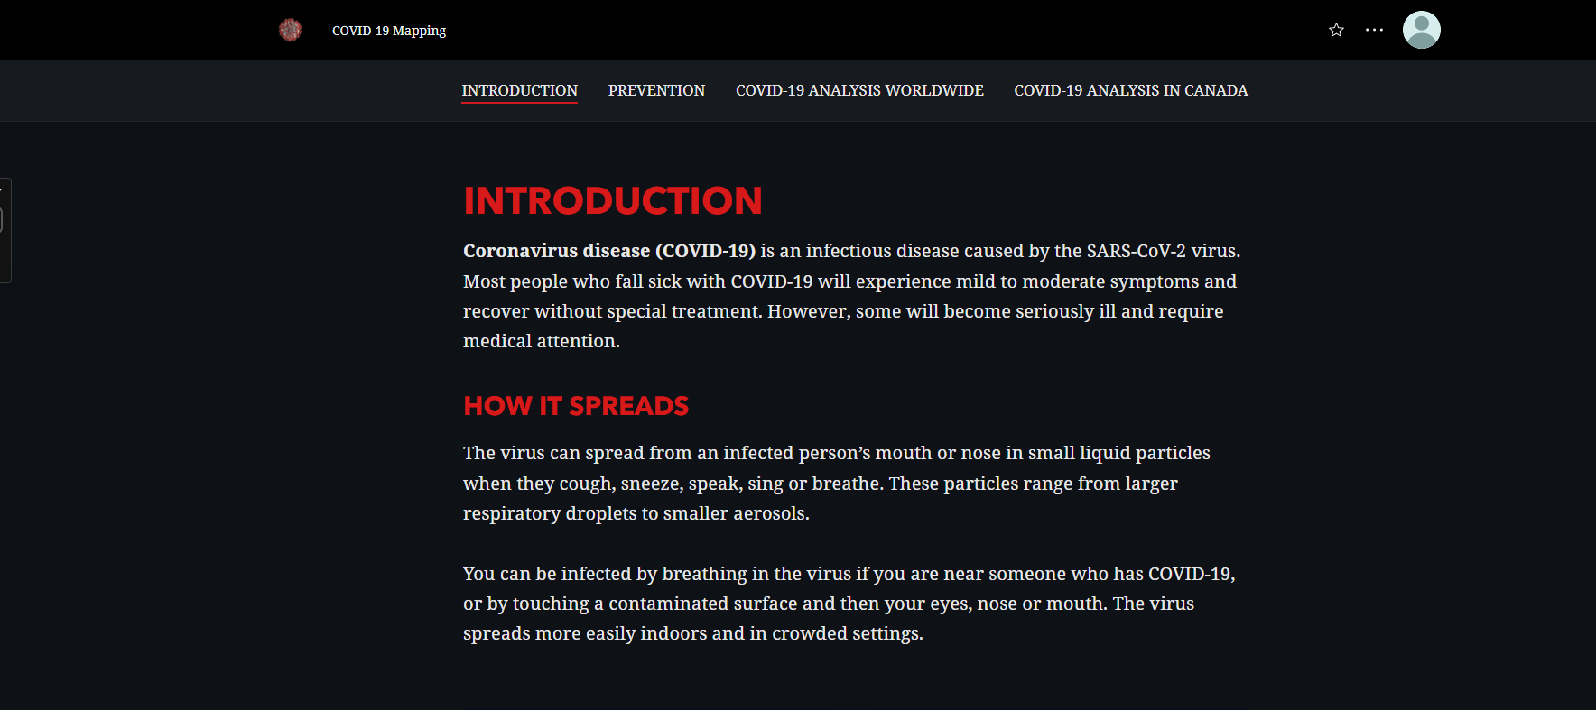

YouTube Video about explaining the virus:



Prevention:

1. Wear Mask.

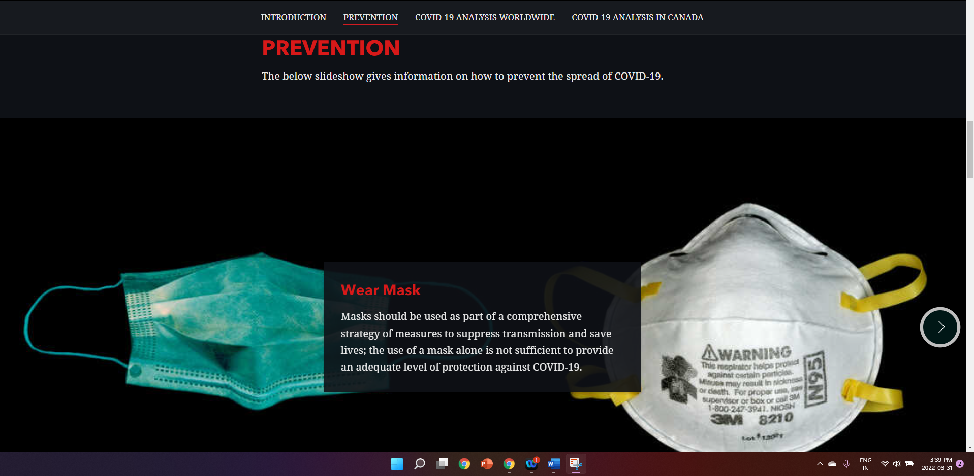

1. Vaccination.



1. Social Distancing.

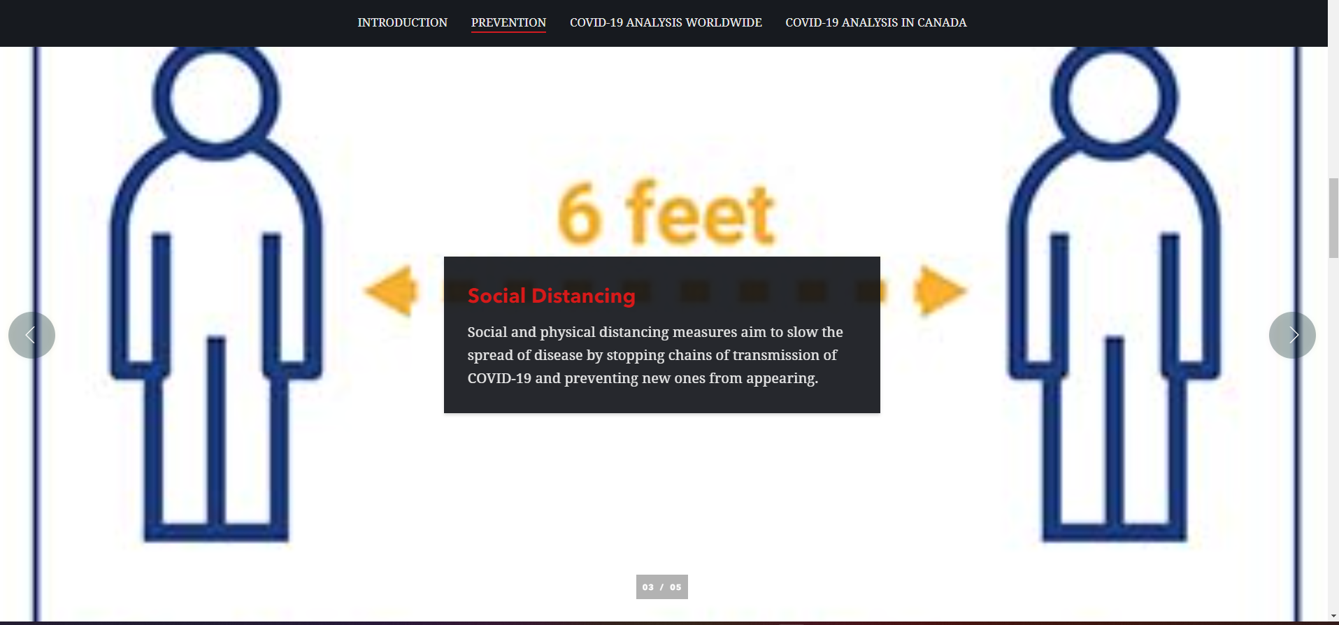

1. Sanitization.



1. Disinfection.

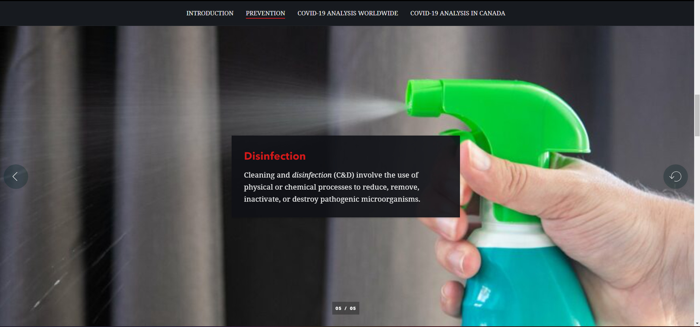

COVID-19 World-wide analysis:

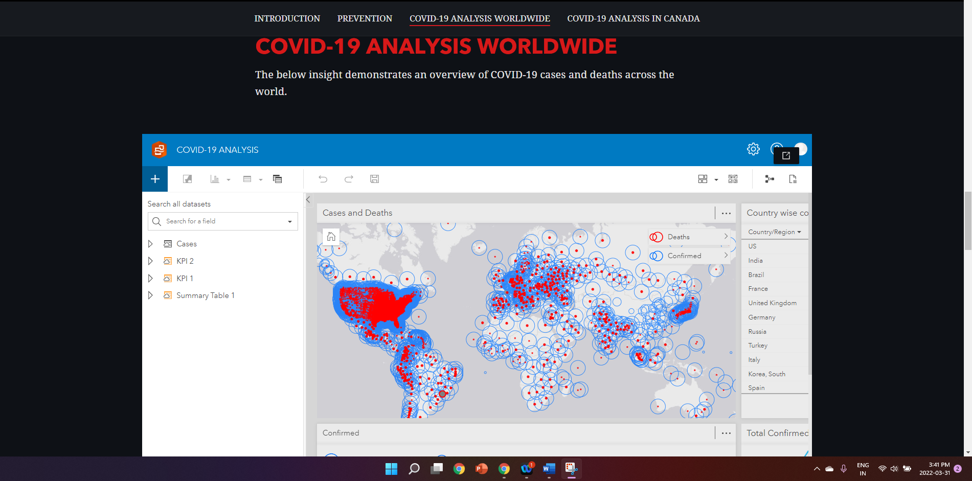

Insights:

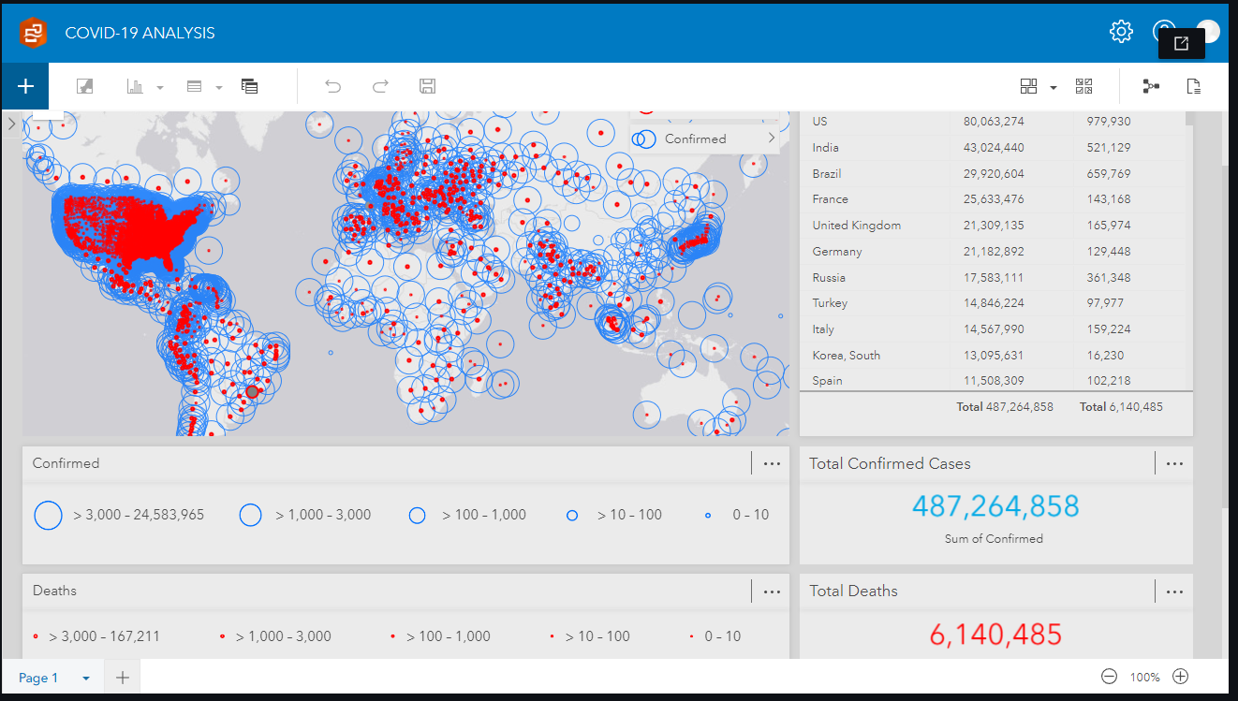

Insight Explanation:

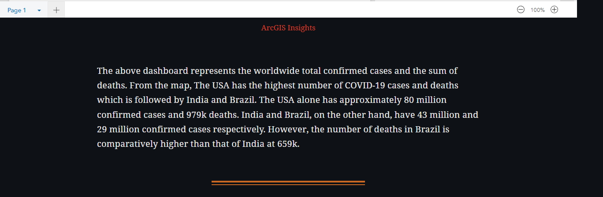

COVID-19 Canada analysis:



Data map starting 1st January:

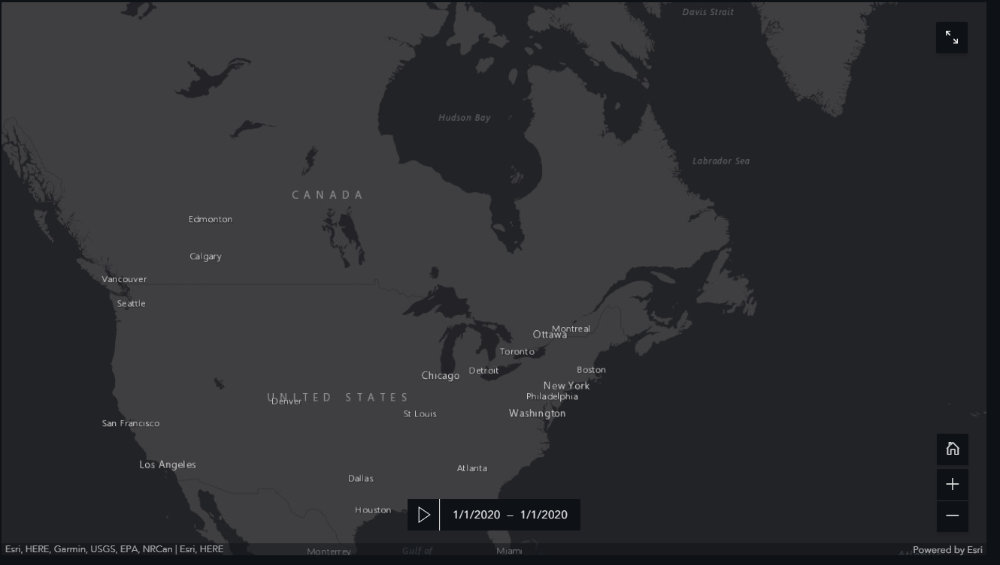

Data map ending 1st April:

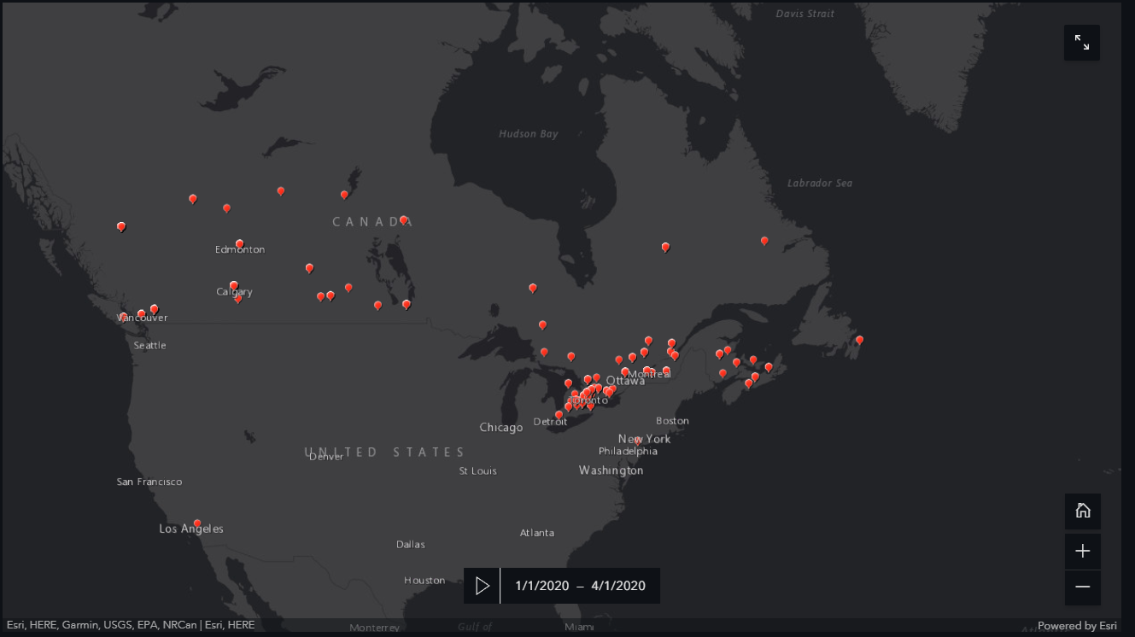

COVID-19 dashboard:

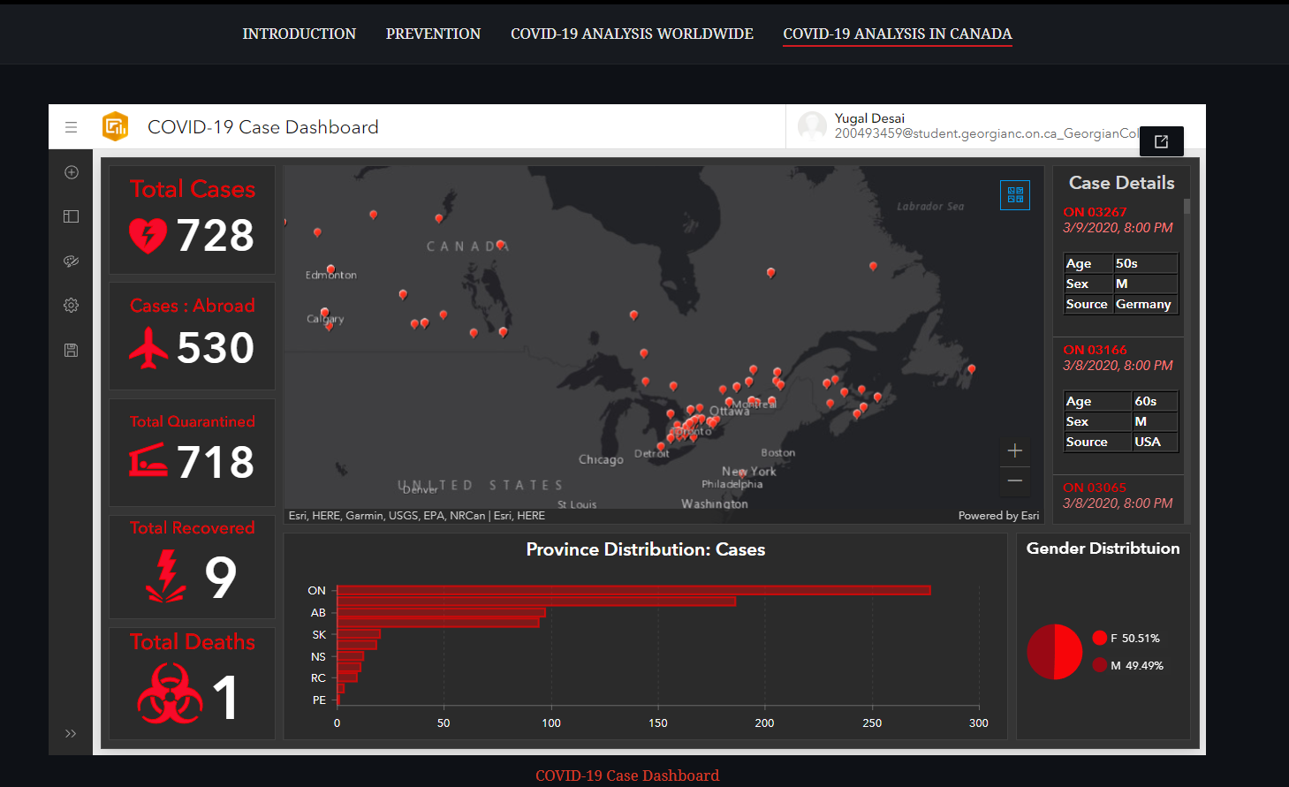

Dashboard explanation:

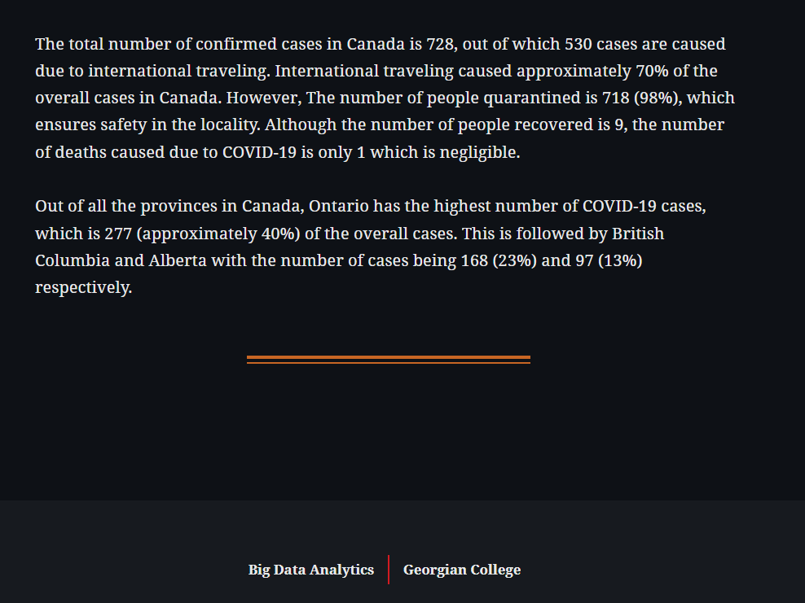

Dashboard and insights are completely interactive. To view, click the below link.

URL of the story map: <https://storymaps.arcgis.com/stories/cd2c05e49f9d4b58a2f6b0164cea6862>